**Creating bucket**

----------------------

Services ----> Storage ----> S3

**Create Bucket**

Bucket Name - (It should be unique globally)

(No uppercase)

(should not contain invalid char like ' , [ # )

Check bucket name restriction in google

bucket name - test-dsgdfsgdfsgdfs123

regions- Mumbai

Next ---> Next --> uncheck block public access ---> Next ----> Create bucket.

Note: Buckets created are available global. Not like Ec2 machines

Observation: We can see global in dashboard.

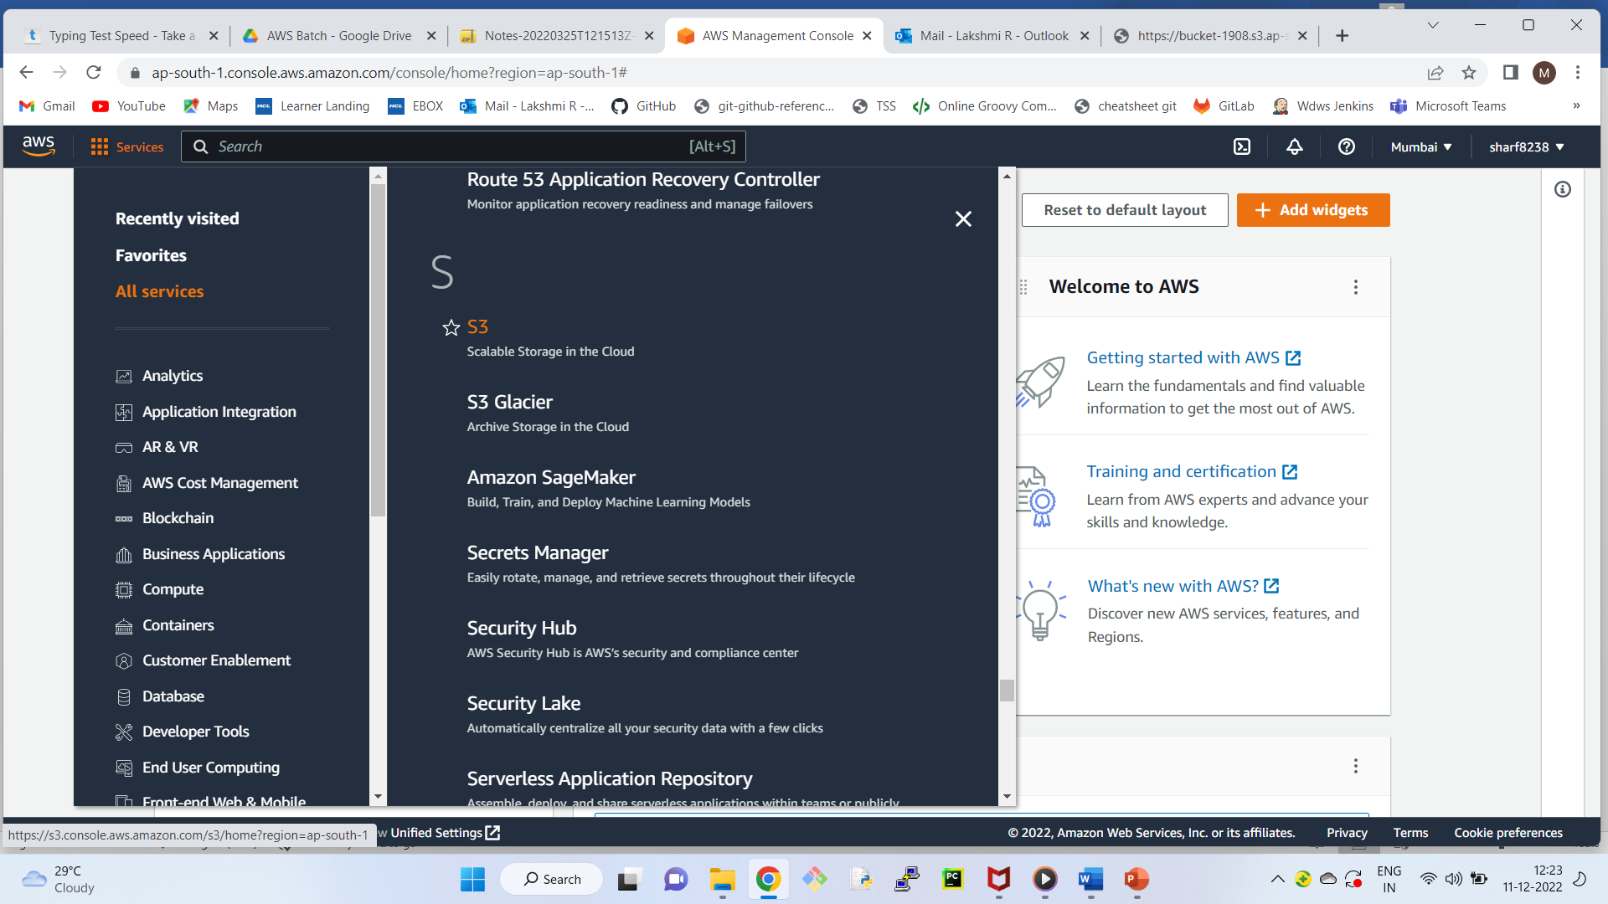

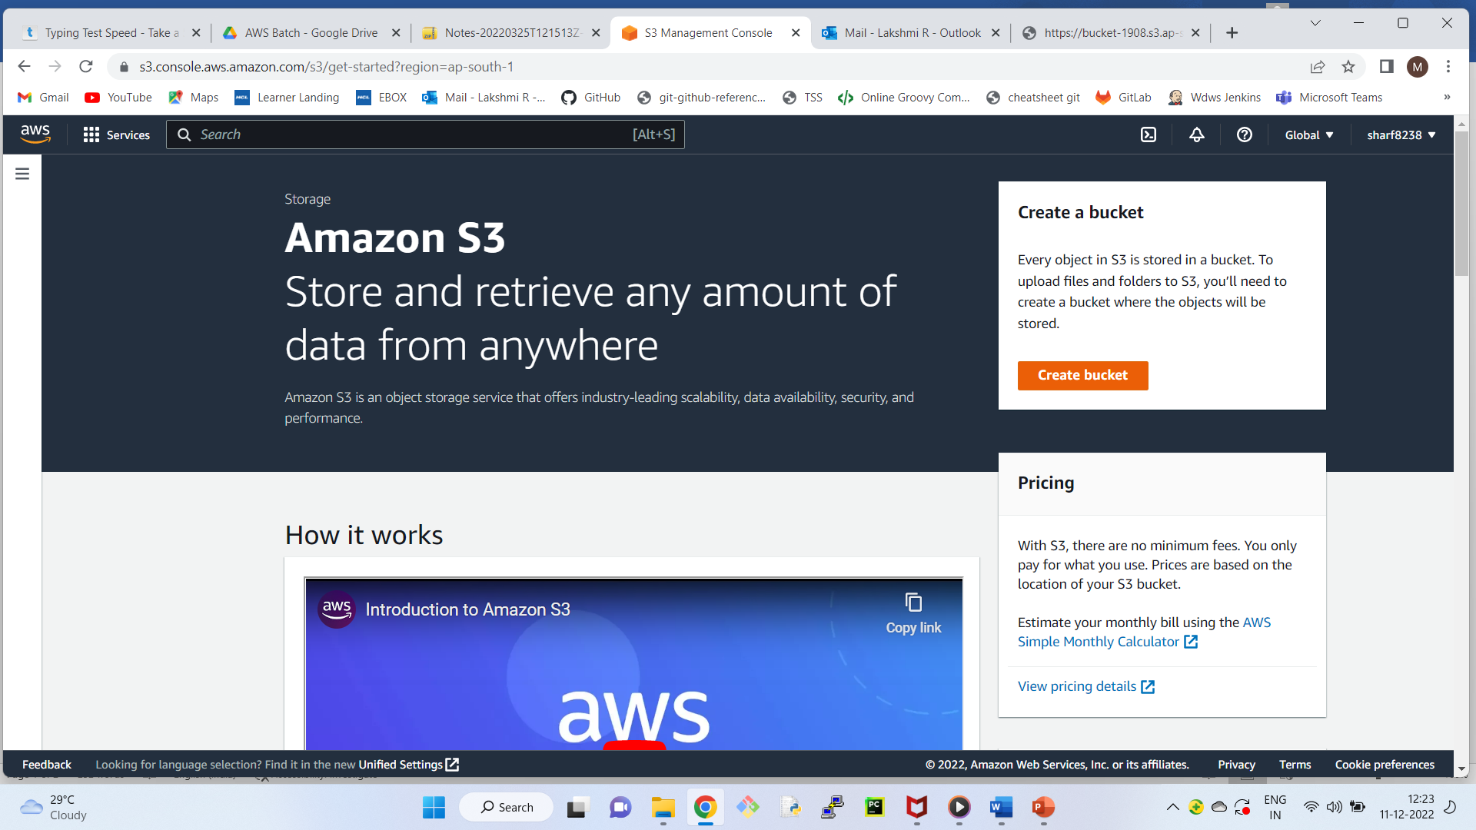

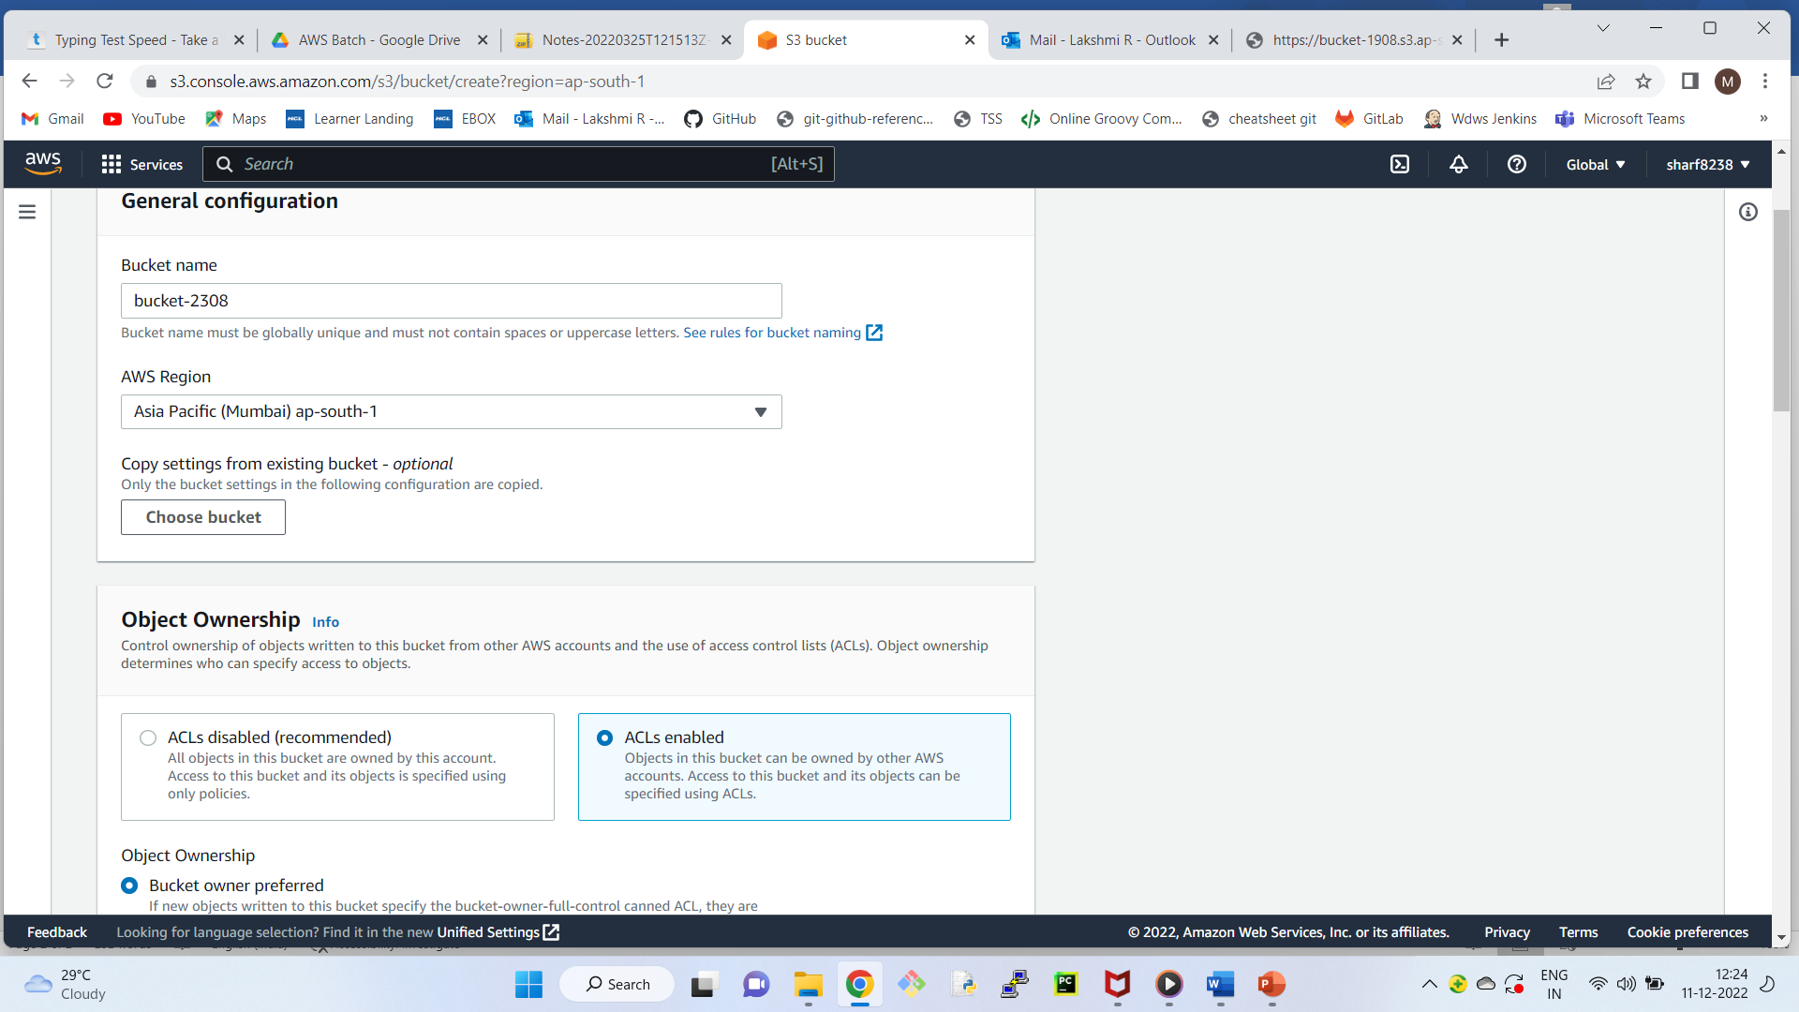

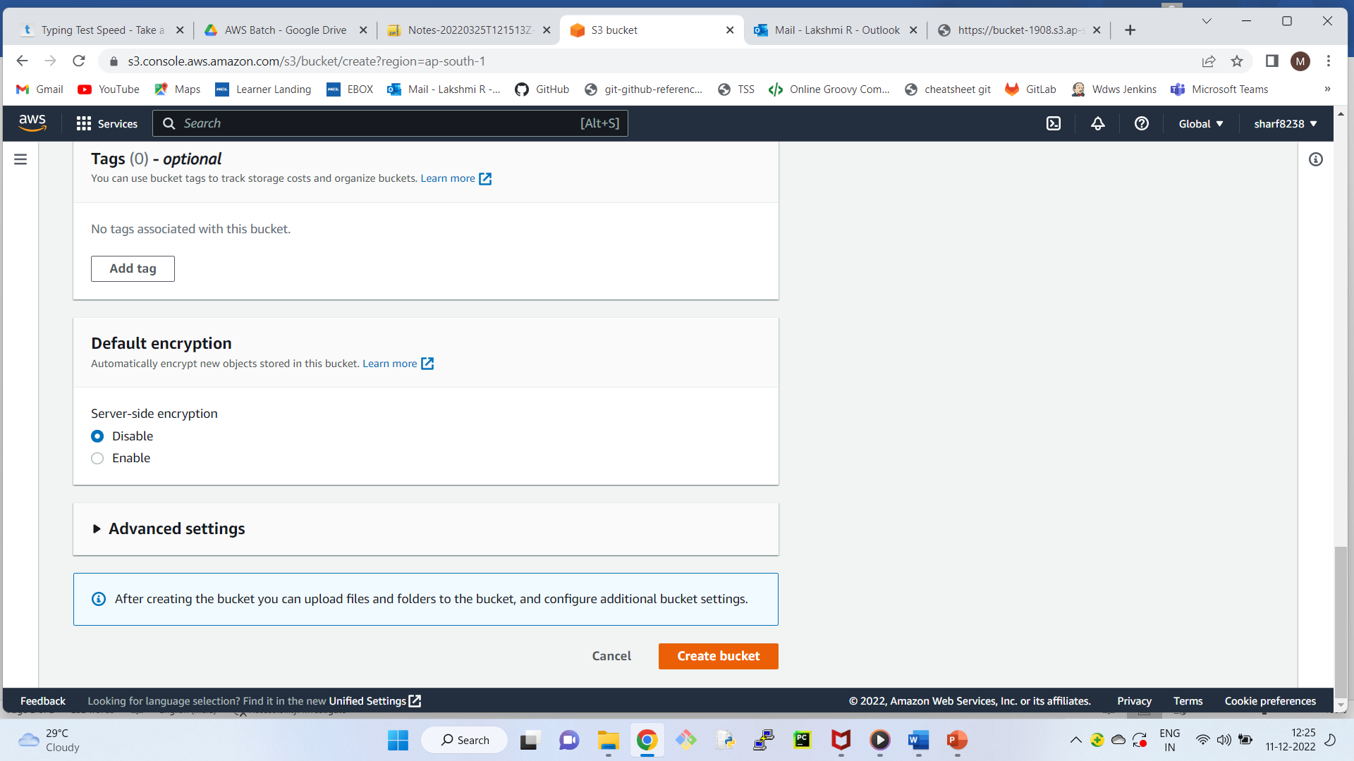

Create another bucket

bucket name - demo-dsgdfsgdfsgdfs123

Select region as - Singapore

Observe: Both the buckets are available in the dashboard.

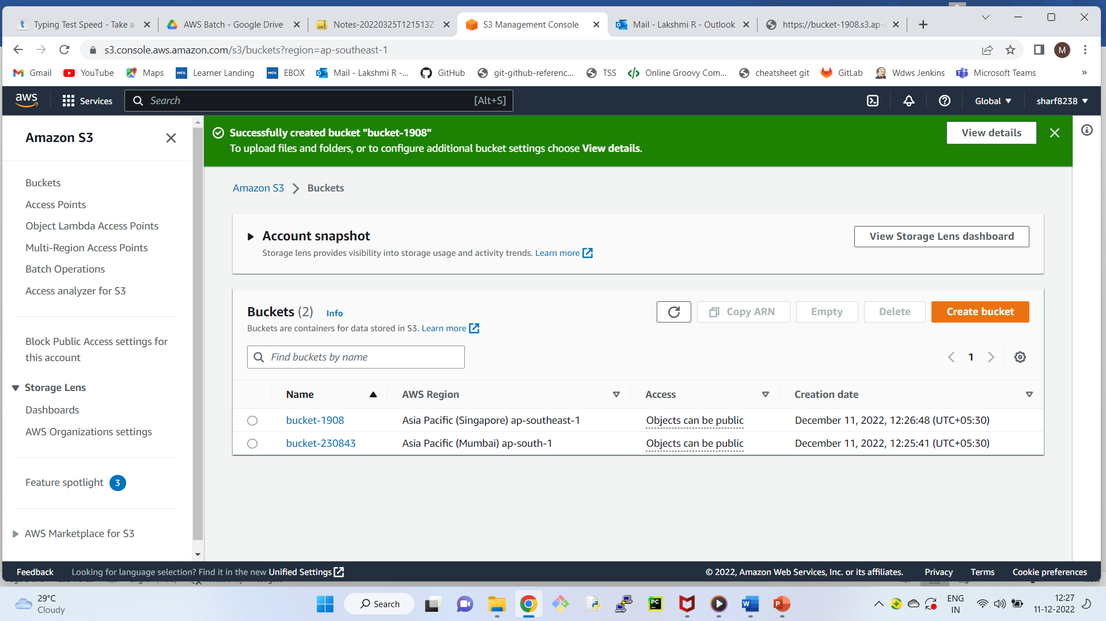

How to Upload the objects (data) in the bucket?

-------------------------------------------------------

click on the test bucket

Upload ---> Add files ---> select any image ---> Next ---> Manage public permissions --> Grant public read access ---> Next ---> Next ---> Upload

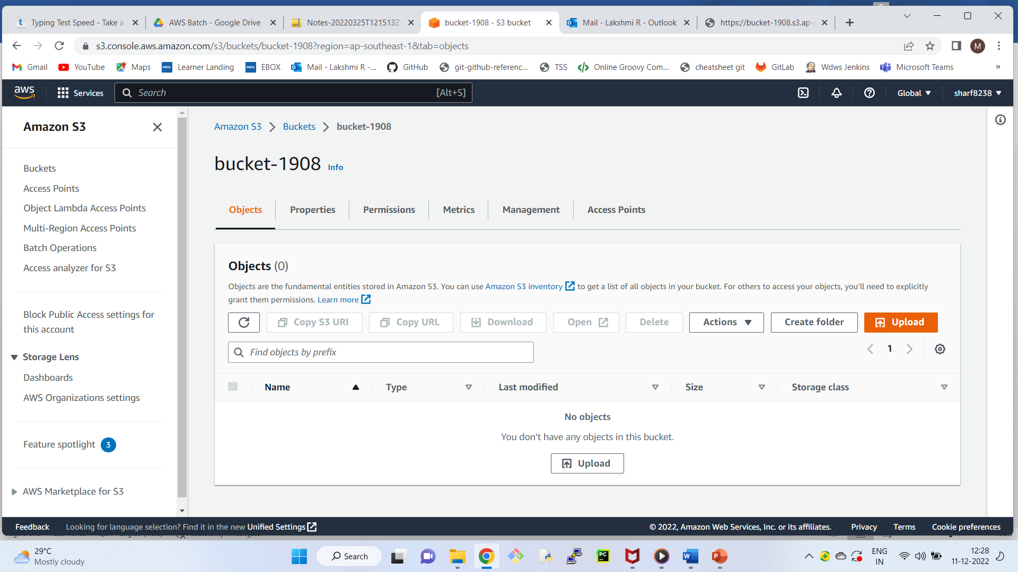

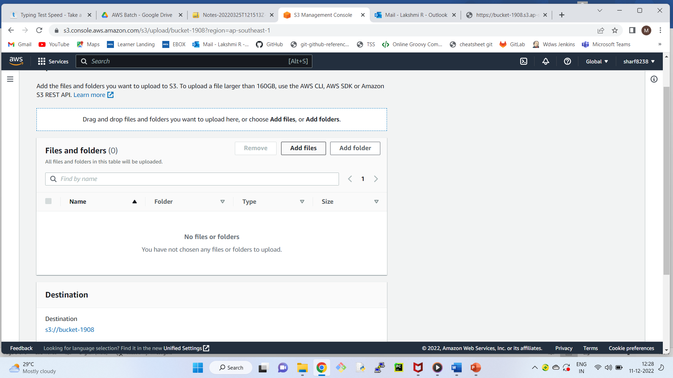

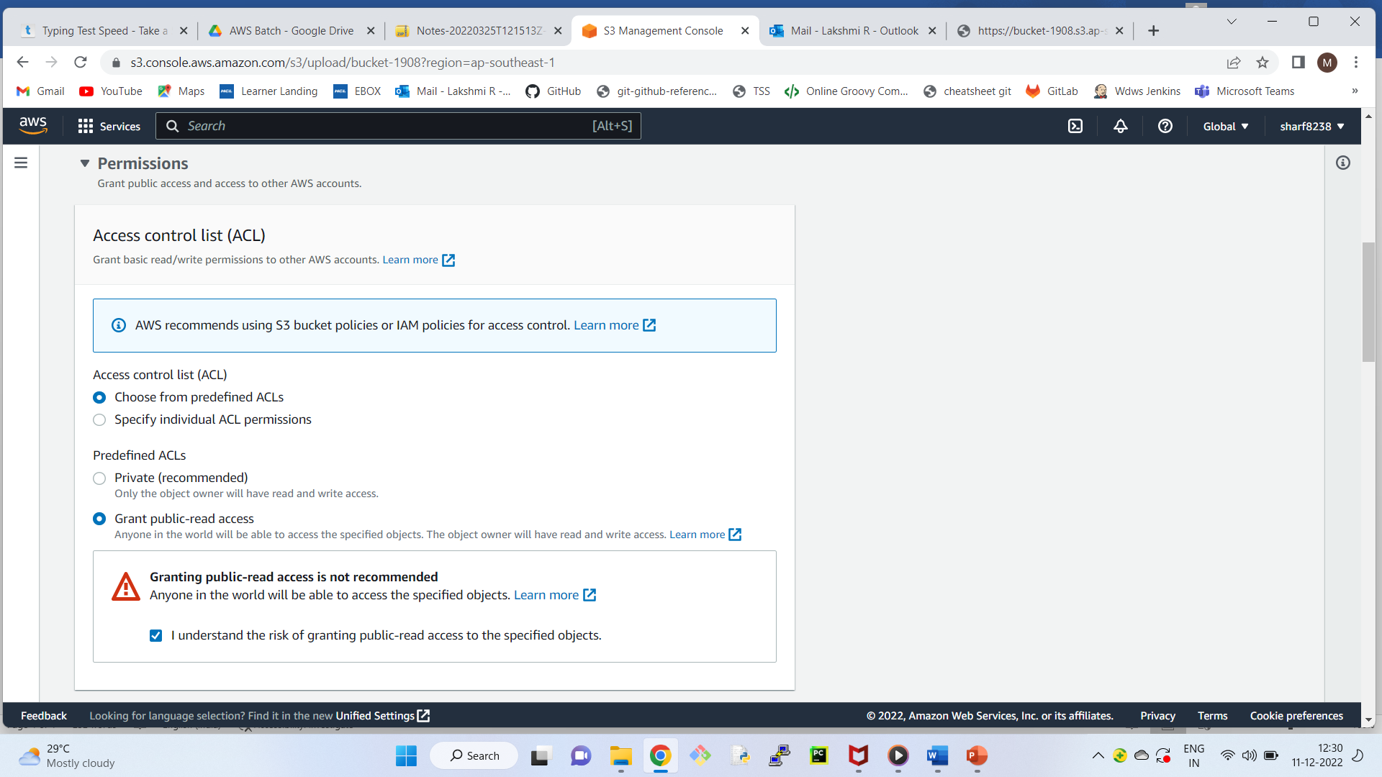

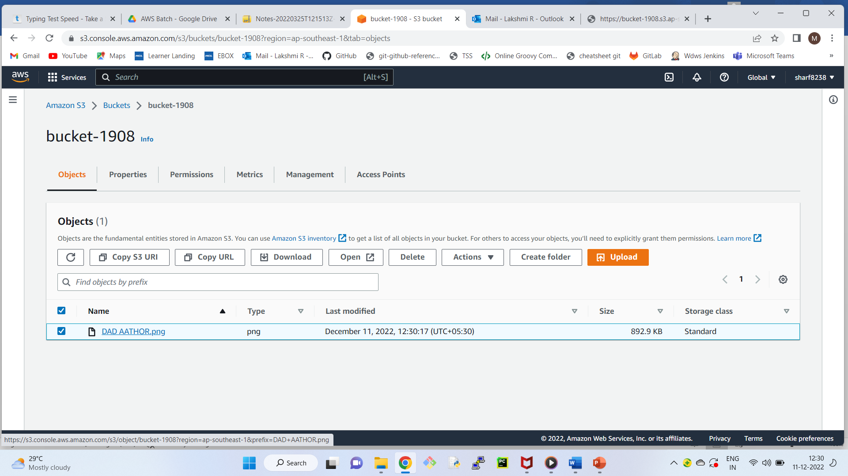

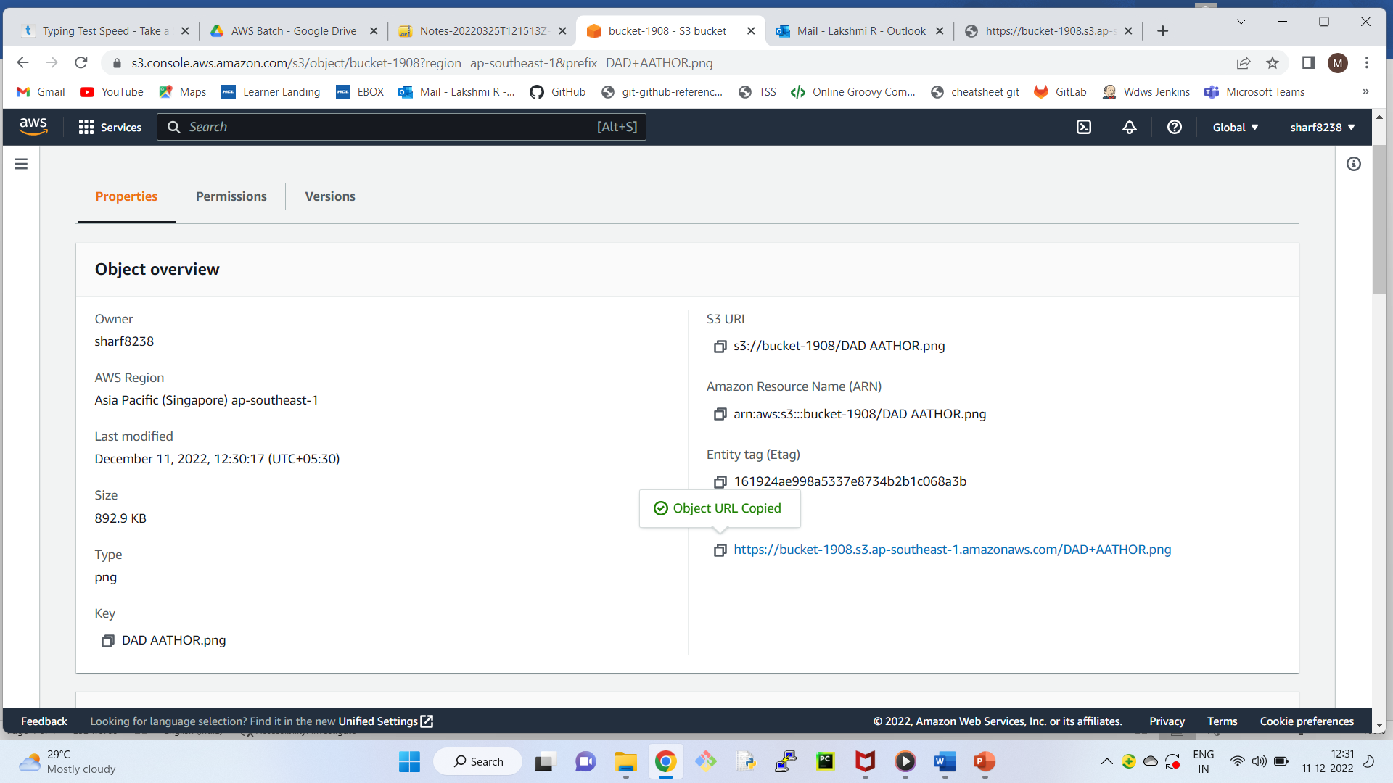

Note: As bucket is public, and object is also public, anyone in the world can access the content.

Click on the Object ---> Get Object URL

Using Object URL, anyone can access.

Copy the URL and paste it in browser you can access the object because it is publicly readable.

**How to make the object private?**

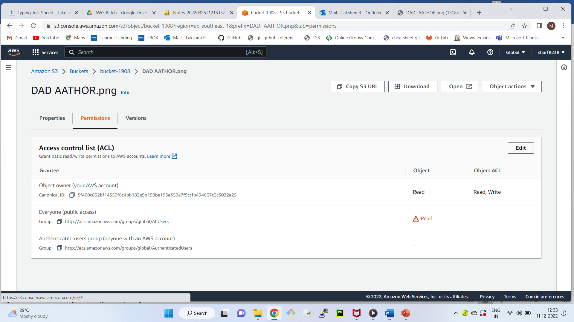

Edit the permissions (Untick everyone (public access))

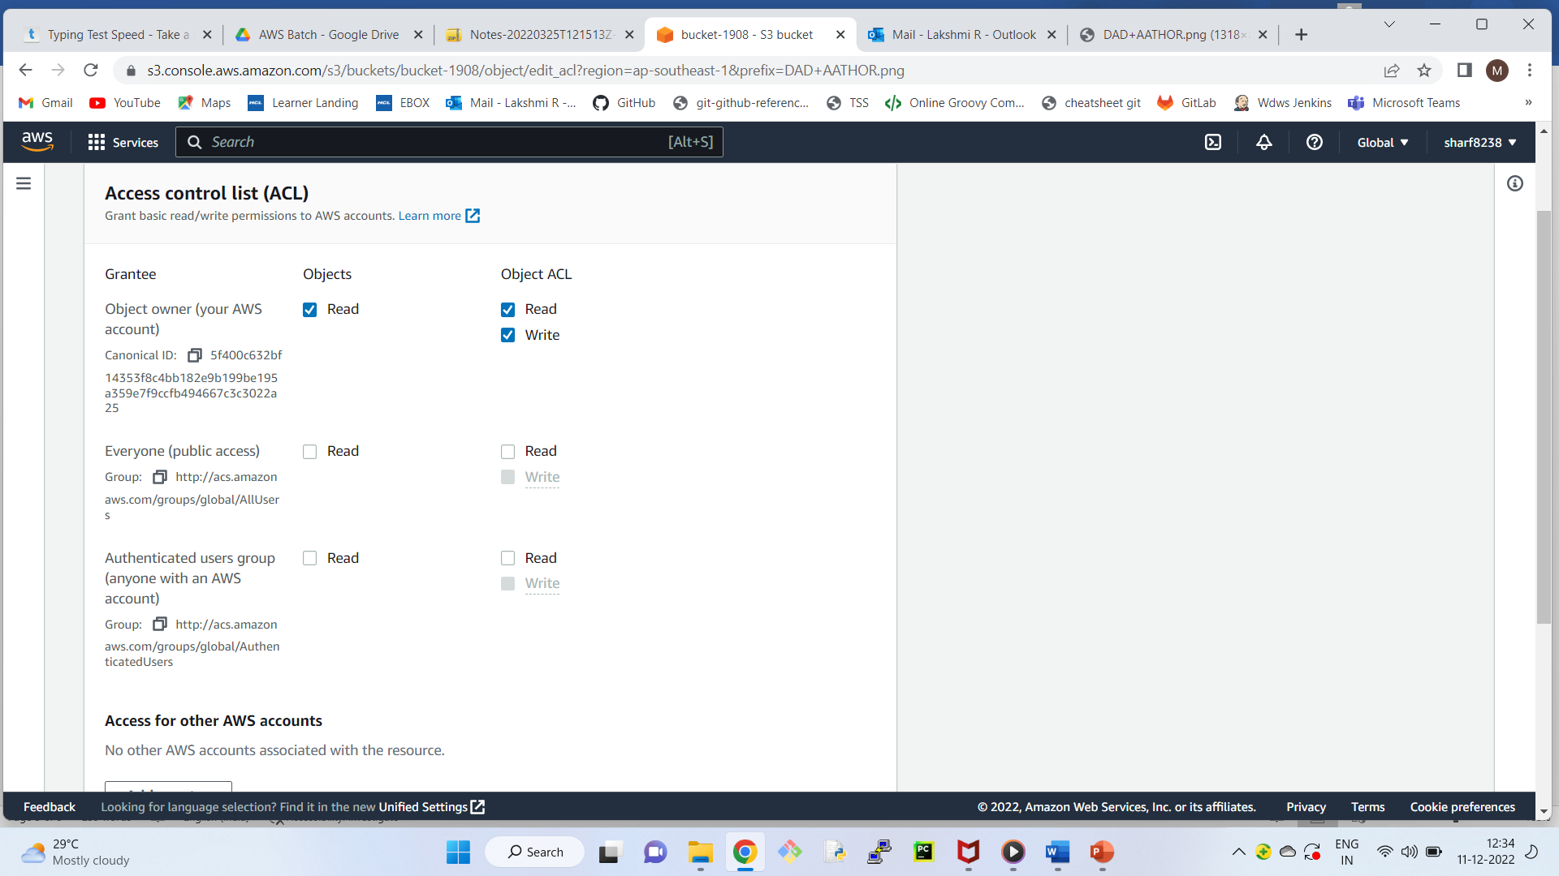

If you check the url. It is access denied now.

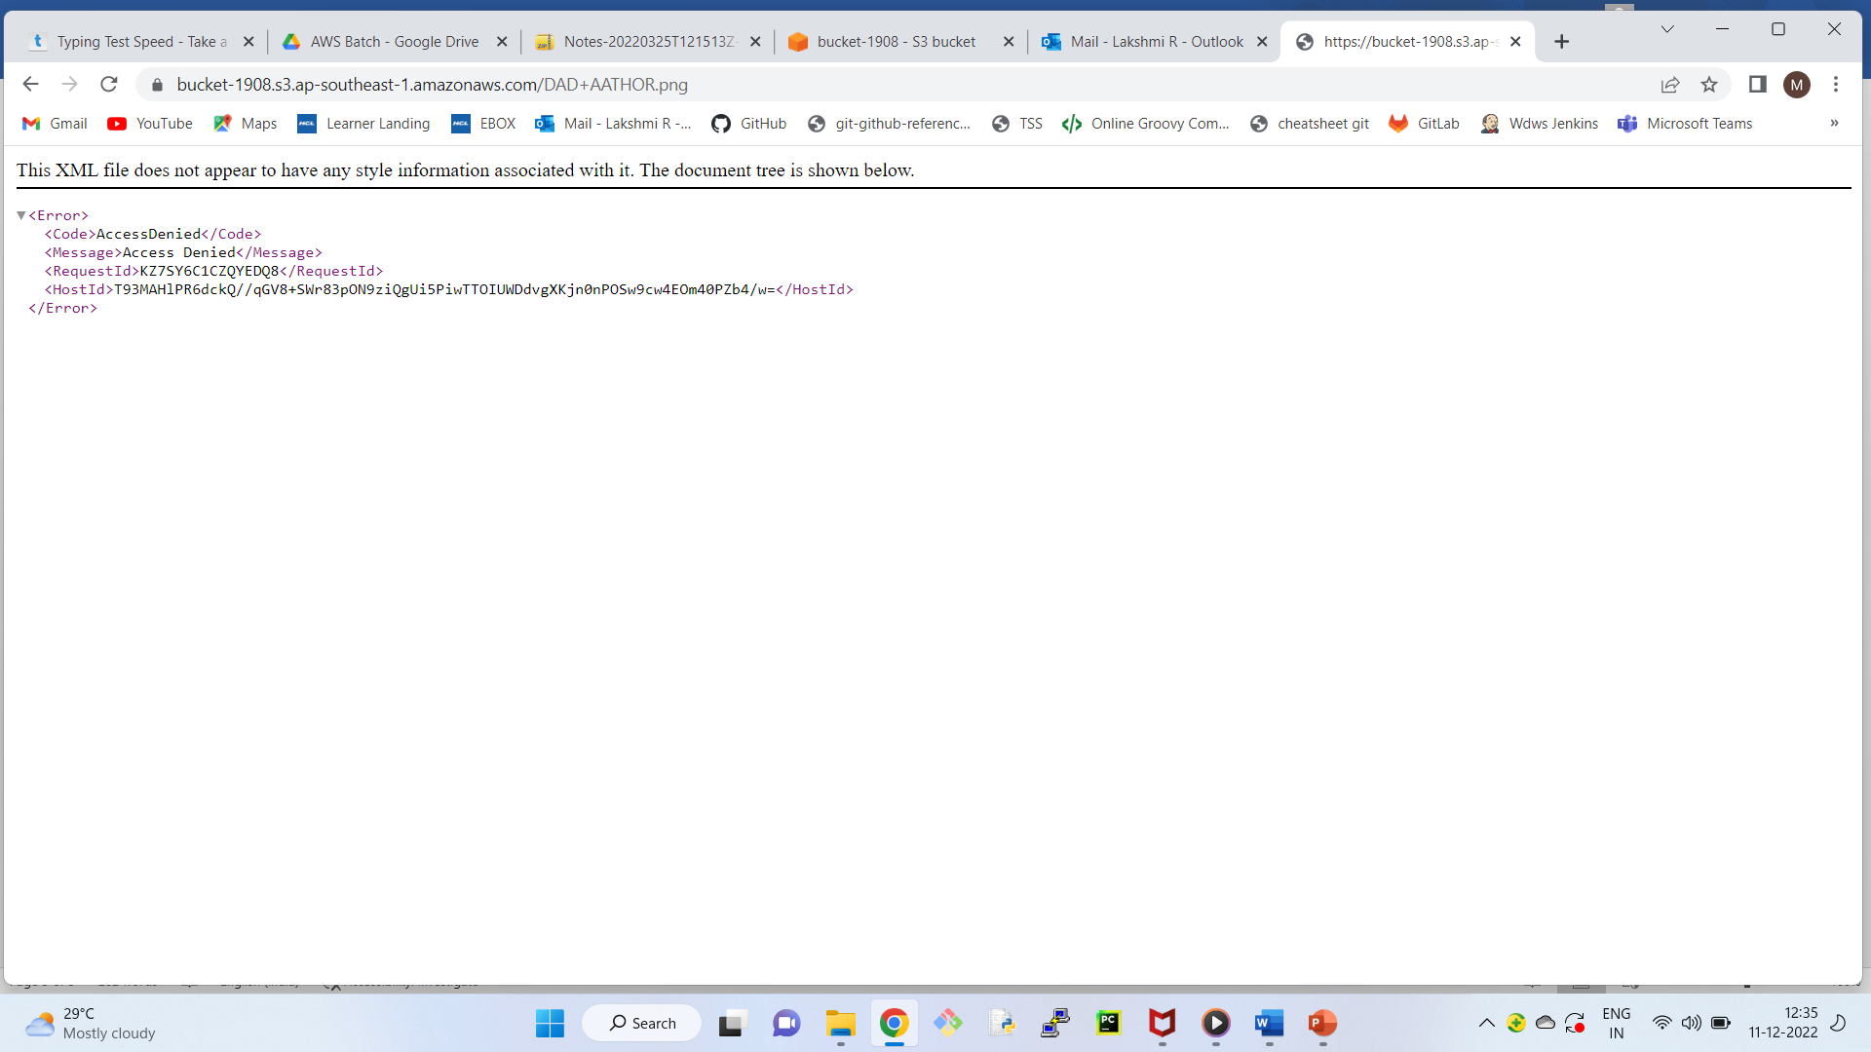

To make it available to public edit permissions.

**Topics**

-----------

1) Versioning

2) Static website hosting

3) classes/ tiers

4) Cross region replication

5) Transfer Acceleration

6) encryption

7) tags

8) metadata

9) ACL

10) Bucket policies

11) Life cycle management

+++++++++++++++++++++++++++++++++++++

Create new bucket

Bucket Name -- version-sfdsafdsafsd

Region - Mumbai

Next ---> Next ---> un check Block all public access

Next ---> create bucket.

How to enable versioning?

----------------------------------

Click on the bucket ---> Properties tab

(Observation: By default version is disabled)

Edit --- Enable

Save Changes.

Let’s upload one object

-------------------------------

Create simple text file, content of the file let it be "My First Line"

Upload the file ---> Next --> Grant public access --> Next --> Next ---> Upload

First advantage of versioning

------------------------------------

We can recover deleted object.

Let’s delete the object.

Select the check box--> Actions ---> Delete

How can we recover?

--------------------------------

Enable list version

We can see the object and its delete marker.

Note: When we delete, object is not deleted.

It is marked as deleted.

So, if you remove the delete marker, we will get the object.

select the delete marker check box ---> Actions ---> Delete --> Delete

Now, Disable list version

Our object is back!!!

2nd advantage: We can maintain different versions of the file

----------------------------------------------------------------------------------

Open the same file in the desktop

Add another line "My second line"

Upload the same file again.

Get the object URL, and check from browser, we get the latest file.

Where can we see the older versions of the file?

----------------------------------------------------------

Show list version

we can see both the versions

and we can download the older versions of the file.

Even if you delete the file, we can recover both the versions.

Select the object --> actions ---> delete ---> delete

select show button

We can see both the versions of the file.

If you delete individual versions, we cannot recover.

Note: If you delete bucket, we cannot recover.

Let’s delete the bucket.

Now, the dashboard is empty.

++++++++++++++++++++++++++++++++++++++

**Static website hosting**

----------------------------

Let’s create a bucket

Bucket name - bucket-3454346

Next ---> Next ---> uncheck block all public access --> Next -----> Create bucket.

Select the bucket ----> Properties ---> Static website hosting ----> Edit --->Enable -- Host a static website ---

index document - index.html

error document - error.html

Save

Now, we need to create index.html and error.html

Upload index.html and error.html ---> Next ---> Next ---> Next -- Upload

Now, go to the properties of the bucket ---> Static website hosting --> get URL of the website (endpoint)

Note: Individual files should have public access.

What is the use of error.html?

----------------------------------

In case of any reason, if index.html is not accessible

then error page will be displayed.

Let’s make the index.html page as private.

select index.html -->ACL --- Edit --> public access -- read - uncheck -- Save Changes

Now, refresh the URL, we get error.html page!!!

Let’s Delete the files ---- and Delete the bucket.

++++++++++++++

**CRR (Cross region replication)**

-----------------------------------------

Let’s say, we have two buckets (1st bucket in Mumbai

2nd bucket in Sydney)

When we upload the object in Mumbai, the object should also be available in Sydney.

As we are replicating an object in another region, it is called cross region replication.

vice-versa will not happen.

If we delete object in Mumbai, it will not be deleted in Sydney.

If we edit object in Mumbai, it will not be edited in Sydney.

Let’s create bucket

bucket name - mumbai-sfsdfgds

Region - mumbai

Next ----> Next ---> uncheck block all public access

Next ---> create bucket.

Let’s create 2nd bucket in Sydney

Let’s create bucket

bucket name - sydney-fhgfhfd

Region - sydney

Next ----> Next ---> uncheck block all public access

Next ---> create bucket.

Enable cross region replication in Mumbai bucket

--------------------------------------------------

Select Mumbai bucket --> Management ---> Replication Rules--> Create Replication Rule ---> Enable Bucket versioning ---> Replication Rule Name - CRR1

Destination bucket --> Sydney bucket --> Enable versioning ---> ---> IAM Role -->

(TO establish connection between two regions, we need role)

IAM Role - Create new role

Save.

Now, let’s upload object in Mumbai bucket, it will be replicated in Sydney bucket!!!!

++++++++++++++++++++++++

**Transfer Acceleration** (Have a look at ppt)

-------------------------

When we enable transfer acceleration, data will be transferred to edge location and then from edge location data will be transferred to bucket.

(Look at the image)

Select mumbai bucket --->Properties ---> Transfer acceleration --->Edit ---> Enabled --- Save Changes.

**How can we check the speed?**

---------------------------------------

Properties -------> Transfer acceleration --> Learn More

Amazon S3 Transfer Acceleration Speed Comparison tool

---> want to compare your data transfer speed by region (open in new tab)

we can compare

S3 direct upload speed

S3 accelerated transfer upload speed.

In this case, we cannot find much difference.

But in longer distances, we can find the difference.

+++++++++++++++++++++++++

**Encryption**

----------------

There are two types of encryptions.

1) AES – 256 (Advanced Encryption standard) - Single encryption

2) AWS - KMS (Key management service) - Double encryption (More secured)

Select the required encryption.

Select the bucket -- Properties ---Default Encryption -- Edit -- Enable

+++++++++++++++++++++++

**Metadata and Tags**

------------------------

Metadata -- To provide more information about the object in key-value pairs.

Keys are pre-defined. eg: Content-type, Content-language etc

tags -- To provide more information about the object in key-value pairs.

Keys and values we need to provide.

Select the object ---> Properties, we can see the metadata and tags.

++++++++++++++++

**ACL and Bucket policy**

------------------------

Select the bucket --> Permissions tab

ACL Edit -- Add grantee

Enter canonical ID -- Save Changes

Note: ACL we can apply at bucket level and object level

Select the Object and provide the access by entering canonical ID

+++++++++++++++++++++++++++++++++++++++++++++++++++++++++++++++++++++

Bucket policy, we can apply only to bucket.

Select the bucket ---> Permission, we can see bucket policy.

Bucket Policy are written in JSON Code.

Bucket policy should be defined in JSON code.

It’s the job of AWS administrator.

+++++++++++

Select any object ---> Permissions tab

Observe: We do not have bucket policy.

As bucket policy, we need to apply at bucket level only.

++++++++++++++++++++++++++++

**Life cycle management**

-----------------------------

Let’s create a new bucket

Select the bucket --> Management tab --> Create lifecycle rule

Rule name - Myrule

This rule applies to all objects -- I Acknowledge

Transit current version of objects between storage classes

Standard 1A -- 30 Days

Add transition

One Zone-IA -- 60 Days

Create Rule

From now, any object uploaded in the bucket will follow the rule for transition.

++++++++++++++++++++